BTT-Writer
Written Translation Computer Support Training
In order to complete this section, you will need an email address that you can check while doing this work. (Of course, you will need some kind of Internet connection, too.)

If BTT-Writer will only be used off-line, i.e. there will not be any uploads or downloads, you don’t need an account on WACS, and you won’t need an email for this section. However, the full power of BTT-Writer is only realized when you upload your work to WACS for safe-keeping.
BTT-Writer can be downloaded by visiting https://bibletranslationtools.org/writer.

The latest version can also be downloaded from https://github.com/Bible-Translation-Tools/BTT-Writer-Desktop/releases/latest or https://github.com/Bible-Translation-Tools/BTT-Writer-Android/releases/latest.
BTT-Writer Desktop and BTT-Writer Android work very similarly, but they are completely different programs. Most of this training is oriented towards use of BTT-Writer Desktop (which can be used on any computer that runs a recent version of Windows, macOS, or Linux). Where there are differences for BTT-Writer Android, we will try to make note of them.
These programs can also generally be downloaded from https://basictranslationtools.org.
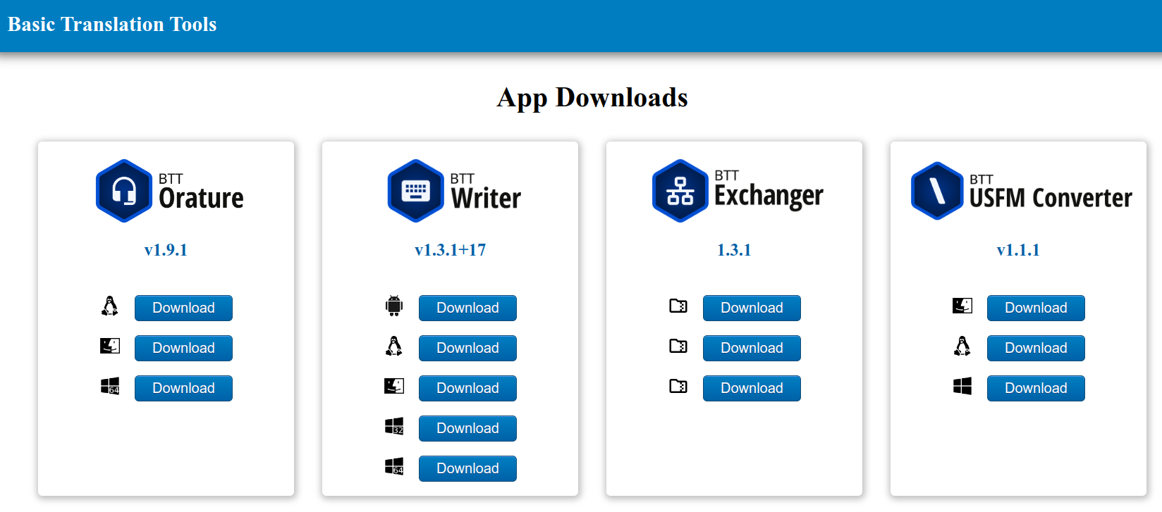

Every current version of BTT-Writer (including for Android) is available for download from Basic Translation Tools https://basictranslationtools.org.

Every current version of BTT-Writer (including for Android) is available for download from Basic Translation Tools https://basictranslationtools.org.

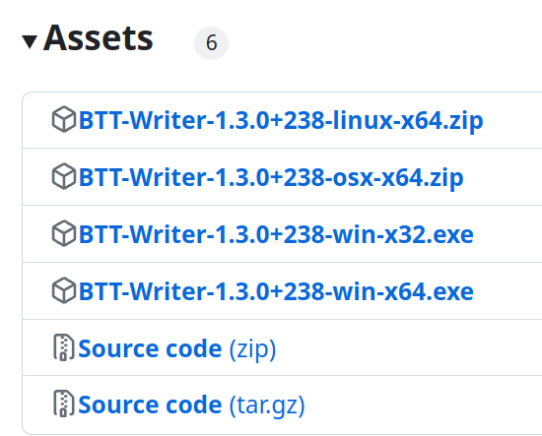
https://youtu.be/Z2mv1uIAE6o
https://youtu.be/UbX-MIRks6c
Installing on macOS
Installing on Linux
Installing on Windows
https://youtu.be/8cj7Iwwc20c
Version
Number

The Windows installer installs git along with BTT-Writer. For Linux and macOS, you will need to install it separately. For macOS we recommend the open-source git-scm available from https://sourceforge.net/projects/git-osx-installer/. You can use Apple’s version of git, but the download is over 2GB, so unless you have that kind of data, it’s better to use git-scm if you can.
Currently, macOS and Linux also need a custom .ssh/config file.

What does BTT-Writer cost? $0
All of the software we make or recommend is free software. Most of it is Open Source software, which means it will always continue to be free.
Do not steal software. Do not pirate software. Do not buy software from the guy down in the market who sells it cheap.
Not only will you be breaking God’s law, you will make your computer more vulnerable to viruses.
There is software that does what you need that is available for free, without stealing from the programmer(s).

Installing BTT-Writer for Android
https://github.com/Bible-Translation-Tools/BTT-Writer-Android/releases/latest
Because of limitations placed by Google on the Play Store, we are unable to have the current version of BTT-Writer available there. Do not use the version that is on the Play Store. It is out of date.
BTT-Writer for Android is downloaded separately. You have to open the .apk file to install.
There is no version of BTT-Writer for iOS (iPhone or iPad).

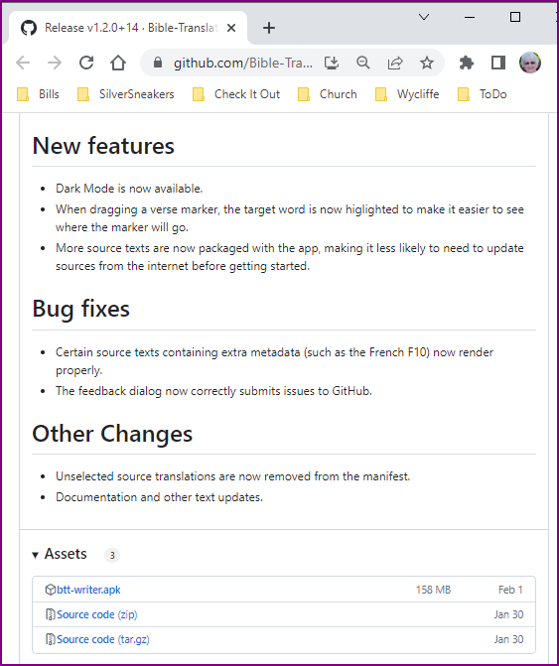
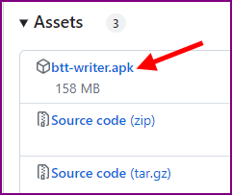
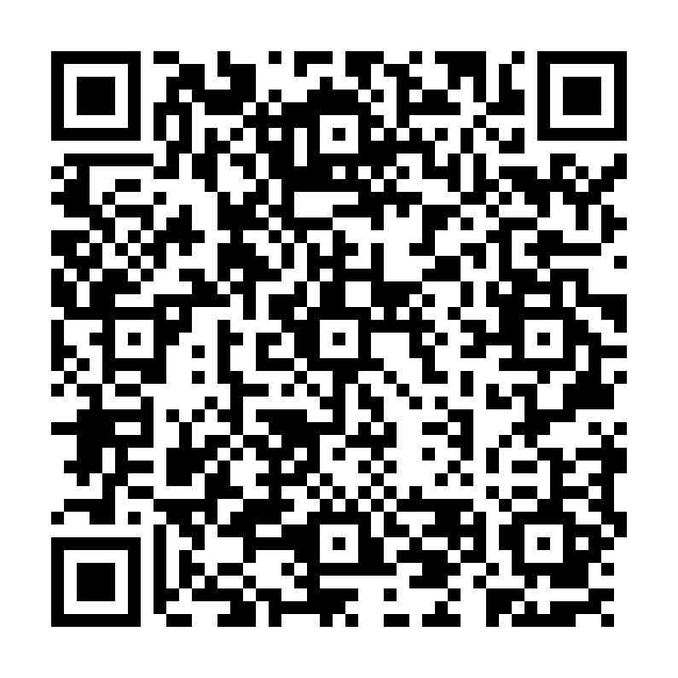

Updates
If you want to be notified when there is a new version of one of our programs, the easiest way is to “watch” the download site. This way, you will receive an email when there is a new release.
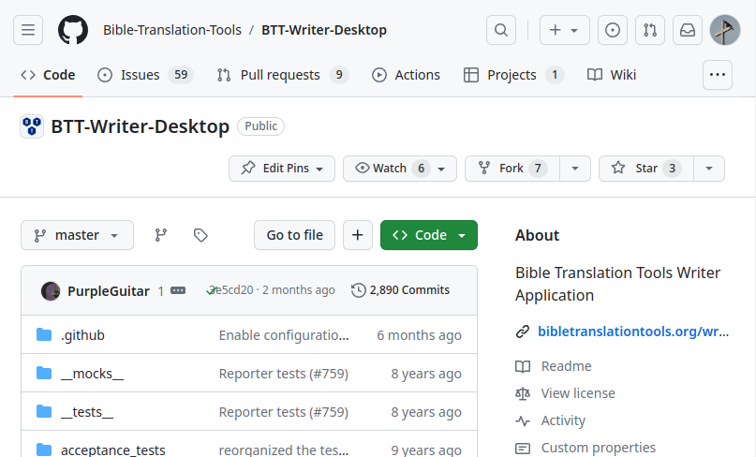
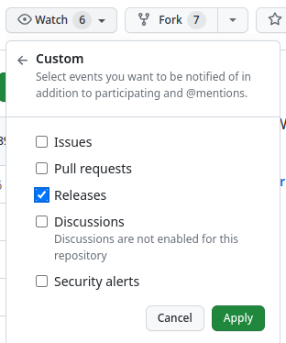

You do need to have an account on Github in order for them to know where to send the notification, but this account is free.
Please note that if you live in a place where your work is dangerous or illegal it is possible for others to discover which projects you are watching. Be mindful of what is needed for your safety.

How Do I Use BTT-Writer?

Full documentation for using BTT-Writer can be found at https://btt-writer.readthedocs.io/

In addition, we have many videos to help on the MAST Tech Talk channel on YouTube: https://www.youtube.com/@masttechtalk1916
Finally, we have many helps at https://techadvancement.com

We also have an active help community on Telegram.

“Logging In” to BTT-Writer
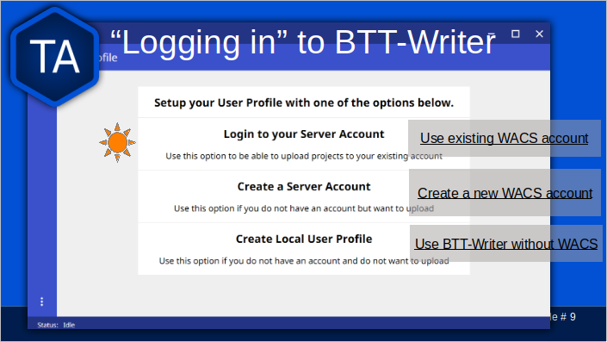
If you have already created an account on WACS, use the first option.
If you have not yet created an account on WACS, use the second option.
Creating an account on WACS is explained in Section 2, PORT, BIEL, and WACS.
Both of these options require an Internet connection, and will connect you to bibletranslationtools.org. If you need to hide this connection, be sure to connect a VPN before using one of these options.
The third option can be used if there is no Internet available, but should always be temporary. For example, you can use it for a typist that you will collect the typing from manually, or if you are away from Internet temporarily.
You should always log out before letting someone else use your computer. This allows them to enter their name into the “Contributors” of the project they work on, and keeps it straight where a project will be uploaded.

Important Agreements: CC BY-SA
All of the content of BTT-Writer is either in the Public Domain or licensed with the Creative Commons license: https://creativecommons.org/licenses/by-sa/4.0/
This means that the translation does belong to the people who did the work, but they are making this translation available for free. There are two restrictions on this license.
BY: Someone who uses the translation must say who he got it from. We call this “attribution”.
SA: Someone who uses the translation must make the end result available under the same license.
The licensor cannot take away these freedoms as long as you follow the license terms.

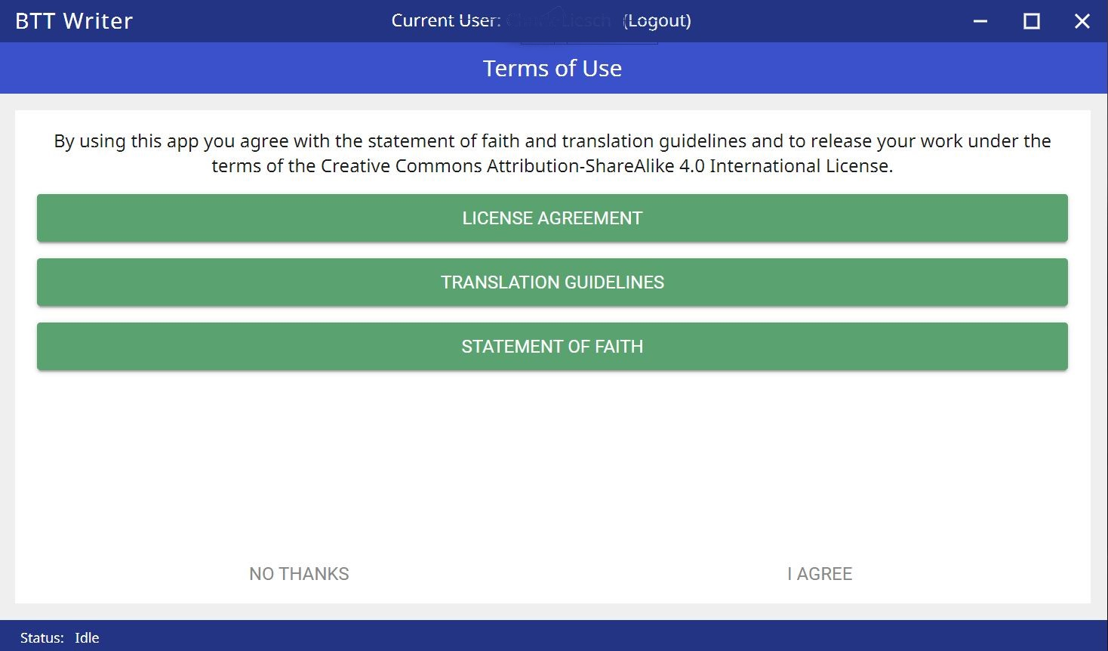
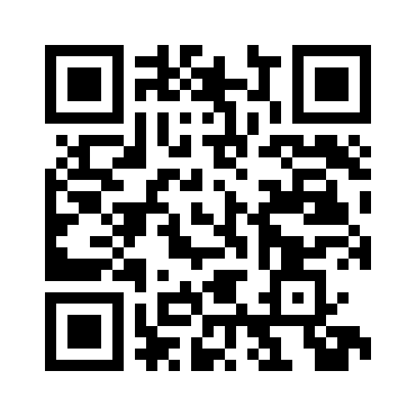

Video #2 Getting Started in BTT Writer for Desktop
https://youtu.be/SXsBXMa8nvw
CC BY-SA License

Important Agreements: Translation Guidelines
Video #2 Getting Started in BTT Writer for Desktop
https://youtu.be/SXsBXMa8nvw
The Translation Guidelines state that a translation needs to be Accurate, Clear, and Natural.

This is not normally something the technician needs to worry about, but it is part of the agreement to use the software.

Accurate
Accurate translations effectively communicate the intended meaning of the original, divinely inspired text. An accurate translation expresses the meaning the author intended for the original audience in the original context.
To the extent that is possible, nothing is added, misconstrued, or deleted from the original message.
It does not recast the meaning of the original text to make it more relevant to the contemporary audience.
An accurate translation does not distort the meaning in order to favor a specific interpretive perspective. It should be free from theological, cultural, or personal biases.
An accurate translation communicates historical events and facts accurately.

Clear
Clear translations will use whatever language structures are needed to help readers easily read and understand it.
A clear translation may use as many or as few terms as necessary to communicate the original meaning as clearly as possible.
Making a clear translation does not mean that the translator clarifies something that is ambiguous in the source text.
Making a clear translation does not mean that the translator gives the reader a specific interpretation for every passage where meaning is genuinely debated.

Natural
Natural translations use language forms that are reflect the way the target language is used in corresponding contexts.
Natural Bible translations sound like they were produced by an adult native speaker who speaks and/or writes well.
A natural Bible translation does not use expressions that are particular to their own culture in order to make the translation appear natural.
It is more important for a portion of Scripture to be translated accurately than for it to sound perfectly natural to everyone who reads it.

We believe that a translation has the highest likelihood of being good quality when after applying the guidelines above, the following are completed:

It is tested and approved by believers of the language community and their church leaders.
Ongoing revisions and improvements are made.

Important Agreements: Statement of Faith
Video #2 Getting Started in BTT Writer for Desktop
https://youtu.be/SXsBXMa8nvw
The Statement of Faith makes sure that we are all working together towards the same goal. While we have seen fruitful work in translation from non-believers, we don’t believe it’s best.

We insist that certain things are true, and not negotiable.
- The Bible is divinely inspired by God and has final authority. This means that we cannot impose our opinions or our culture on the content of the Bible.
- God is one and exists in three persons: God the Father, God the Son, and God the Holy Spirit.
- Because of the fall of man, all humans are sinful and in need of salvation.
- The death of Christ is a substitute for sinners and provides for the cleansing of those who believe.
- By God’s grace, through faith, people receive salvation as a free gift because of Jesus’ death and resurrection.
- The resurrection of all at the end of time — the saved to eternal life and the lost to eternal punishment.

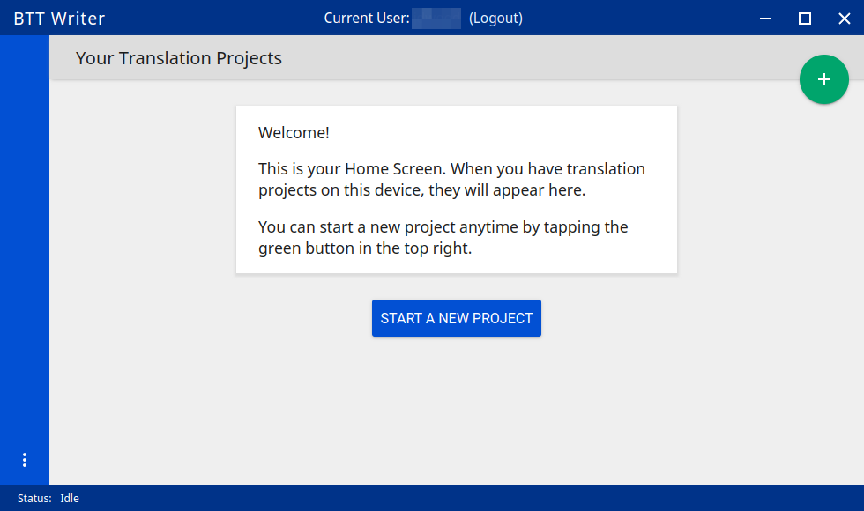
BTT-Writer Home Screen
Logout is only used when a different translator is going to use the program, or to switch between on-line and off-line use.
Create a new project by clicking either the green button at the top right, or the Start a New Project button.
The “3 dot”, or “Hamburger”, menu

Once a project has been created, the project list fills in the space where the Start a New Project button is, so you can only use it for the first project.
We will normally refer to the Hamburger menu as the 3 dot menu.
Occasionally, BTT-Writer will get confused about whether you’re logged in to WACS or not. If this happens (and you can’t upload) you can often fix the problem by clicking Logout and logging back in again. You will need to click I Agree to the three agreements each time you log in.

Hamburger Menu (3 Dots)
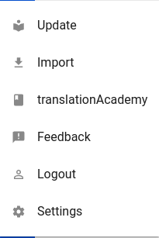
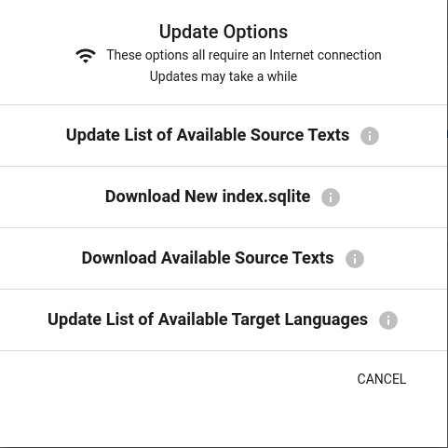
Check to see if there is a new GL in the catalog, or an update to a GL.
Download a complete copy of the database.
If there is an updated or new Source, this will let you choose what to download
Check to see if there are any new language codes.
BTT-Writer keeps a database of available Source Texts, or Gateway Language (GL) texts. The database also keeps a list of available Target Language codes, for translation projects. In addition, BTT-Writer stores Source Texts on your hard disk drive, ready to be used for a translation project.
Every time BTT-Writer is updated, the new release will include all of the sources available at that time. It will also include all of the target language codes currently available. However, over time, new codes will be added, and sometimes language names will be spelled differently, although they keep the same codes.
The process to update the codes and Source Text versions can take a long time, and because it uses an Internet connection, it can time out while you are trying to update. This can be very frustrating, so we have another choice for you.
Each week, a database file with all of the most up-to-date language codes and Source Text versions is posted online. Download New index.sqlite will download this database and simply replace your existing database. It could be out of date for as much as a week, but never more than that.
Every language in the world has a code to identify it as being separate from other languages. For example, we are currently aware of four languages called “Kamba”. One of them, in Kenya, has the code kam. The related language in neighboring Tanzania has the code kam-TZ-kamba. The languages in PNG and Brazil have the codes fad-x-kamba and xba, respectively.
If a minority language does not yet have a code in our system, the translation project managers need to communicate with their supervisors to get the code added in PORT. Then, in a week or so, or after running the Update List of Available Target Languages, the new code will be available.
It is very important to use the correct code for the language. If you are unsure of what the code is, ask the project manager.

Updating Sources
The circular green arrow indicates that there’s an update for this source. Click on the arrow to update.
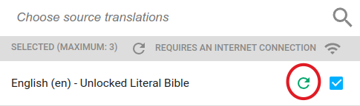
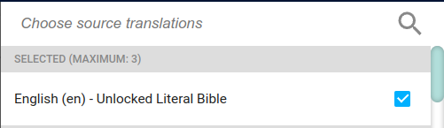
However, don’t update unless either the Project Manager asks you to do so, or you haven’t yet begun translating that particular book. Otherwise there may be changes that will make checking difficult.
No update is available or needed

Updating Source Texts (GL) is a two-step process. It is not usually a good idea to change the content of the source text while translation is happening. (It makes it difficult to check.) Therefore, the first part of the update is to see what updates are available.
Once you have been notified that an update is available, you can see if it’s available for your current project when you select sources for that project.
A circular green arrow appears by sources that have updates available.

