Steps on BTT-Writer for a translator:
- Open BTT-Writer and Login with internet account or Local account. (Please use Full Name or Pseudonym — always use the same name)
- Agree with License, Translation Guidelines & Statement of Faith.
- Click the 3 dots in the lower left, then Settings. Make sure Blind mode is enabled and Gateway Mode is disabled (unless working on GL).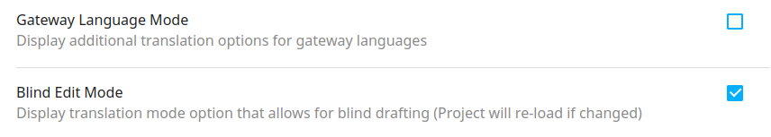
- Start a New Project. (Jump to 6 if you are going to continue on an existing project.)
  - Select the Target Language.
  - Select Old Testament or New Testament.
  - Select the book.
  - Select the source.
- Remember the MAST Steps:
  - Use Read for Steps 1 & 2
    - Step 1: Consume
    - Step 2: Verbalize
  - Use Blind Edit for Steps 3 & 4
    - Step 3: Chunk
    - Step 4: Blind Draft
  - Use Edit and Review Mode for steps 5 to 8:
    - Step 5: Self-Check
    - Step 6: Peer-Check
    - Step 7: Key Word Check
    - Step 8: Verse-by-Verse Check
- Continue a project.
  - Select the book and remember to use the Read for Steps 1 and 2, Blind Mode for Steps 3 and 4, and use Edit and Review Mode for steps 5 to 8.
- End of the day.
- Make a Backup on USB and WACS if you have an internet account.
  - Click the 3 dots in the lower left, then choose settings.
  - A Menu will pop up
  - Select Upload/Export
    - Upload to Server:
Will connect over the Internet to WACS.
    - Export Project File: (For USB)
Bundles everything included in the project and zips it up for export. This creates a .tstudio project file.

